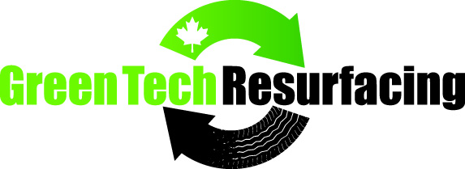

5 year warranty on rubber
1 year warranty on installation

Green Tech Guarantee:
Green Tech Resurfacing guarantees all labor and workmanship for 1 year from completion date and a 5 year warranty for cracks on our rubber product.
Green Tech Resurfacing will:
- Install our proprietary rubber crumb along with a poly-urethane binding system.
- Supply all installation materials, labor and equipment required to complete resurfacing areas as agreed upon by client
- Conduct a site inspection pre-installation to ensure the area is cleared of all debris, is dry and ready for application. Rubber paving installation will not occur if site is not properly prepared. Homeowner must contact contractor well in advance if the site is not ready for installation for any reason.
- Ensure that the rubber crumb remains dry at all times and will be covered if delivered to the site early. (rubber will cure too fast if it comes in contact with any moisture).
- Fix any damaged areas due to installation errors or defect in product.
- Insure its operations under a comprehensive liability insurance coverage not less than
$3 000 000 inclusive per occurrence against bodily injury, personal injury and property damage. All contractors will be registered with WCB and coverage will remain intact throughout the installation.
- Protect all areas adjacent to the work area from damage resulting from installation through use of tarps.
- Clean up garbage and installation debris daily and leave the site clean upon completion.
- Stand behind its work and shall remain committed to providing a quality rubber resurfacing product to the homeowner.
*Resurfaced area cannot be used until it is fully cured (24 hours minimum) Warranty is compromised if paved area is walked or driven on before surface has been fully cured.*

Nelson Baziuk
Green Tech Resurfacing Ltd.

